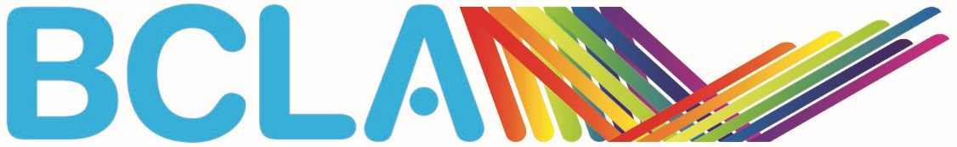

BCLA 2021 Young UK Contact Lens Practitioner of the Year Nomination Form

Name of nominee
Contact details of nominee
Email
Telephone number
Please describe below how you meet the nomination criteria (1,000 words maximum)
(Please attach a separate page, if required)
Nominator
Date

Please return the nomination form by Monday 3 May 2021 together with any additional documentation such as patient and/or colleague testimonials, images, scans, topography maps etc to membership@bcla.org.uk.

